ModElec User Manual

This document aims to provide detailed information about the installation and operation of ModElec. The following sections describe the structure of ModElec tool package, installation steps, circuit preparation, and ModElec tool interfaces.

# ModElec Structure and Files

The *ModElec* directory contains the following subdirectories and files (Figure 1). The first two files (in light red) are the primary Grasshopper files.

* **3DPackageCreator.gh:** the tool for the user to create custom 3D models for the electronic components.
* **ModelecMainInterface.gh:** the ModElec tool for the user to integrate electronic parts into 3D models.
* **CustomModels:** the subdirectory that contains some custom 3D models of electronic parts.
* **dll:** the subdirectory that contains all the libraries the tool needs.
* **ElectronicPartModels:** the subdirectory that contains the electronic components provided with Fritzing, Sparkfun, and HP Cadence libraries.
* **humanui:** the subdirectory that contains Human UI files for Grasshopper.
* **ModelecComponents:** the subdirectory that contains all the resource files for the tools.
* **PrinterProfile:** the subdirectory that contains the specifications of the 3D printer (JSON files).

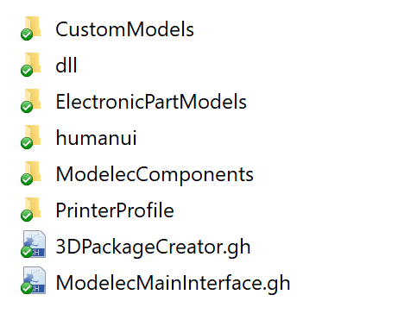

Figure 1. The directory structure of *ModElec*

# Dependent Software and ModElec Configuration

1. Install Rhino 3D 5, 6, or 7: <https://www.rhino3d.com/>
2. Install [Grasshopper](https://www.grasshopper3d.com/page/download-1) and [Human UI](https://www.food4rhino.com/app/human-ui#downloads_list) addon (Grasshopper is built in Rhino 6 and 7. Human UI needs to be installed manually).
3. Download the *Modelec* folder from Google Drive and save it at a place on the local computer.
4. Launch Rhino and open the *Grasshopper Developer Settings* dialogue. Add the ModElec bin folder to the library folder: **<The folder where the Modelec folder is saved>\Modelec\ModelecComponents\bin\** (Figure 2).

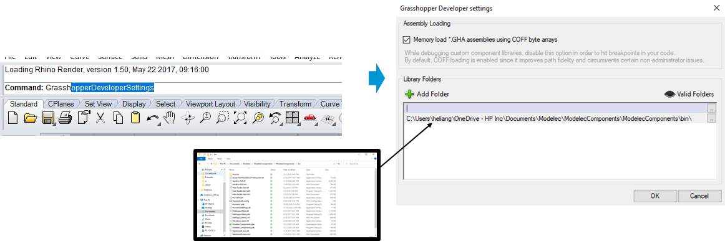

Figure 2. Configure the library path in Rhino.

1. Turn on “Osnap” and turn off “Gumball”. Turn on snapping to “Point” (Figure 3).

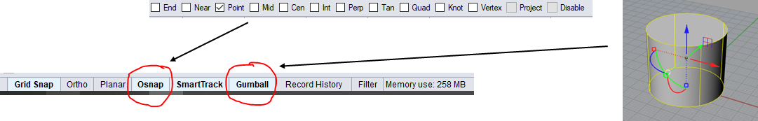

Figure 3. Mouse settings in Rhino.

# Circuit Preparation

Currently, ModElec supports circuits created with three different third-party circuit EDA tools—Cadence, Fritzing, and Autodesk Eagle. Figure 4 shows an example of circuits created with different software. **Note that all the files exported from the same software should share the same file name except for the file extensions.** All the example files are on Google Drive: **/ModElec/ExampleCircuits/**

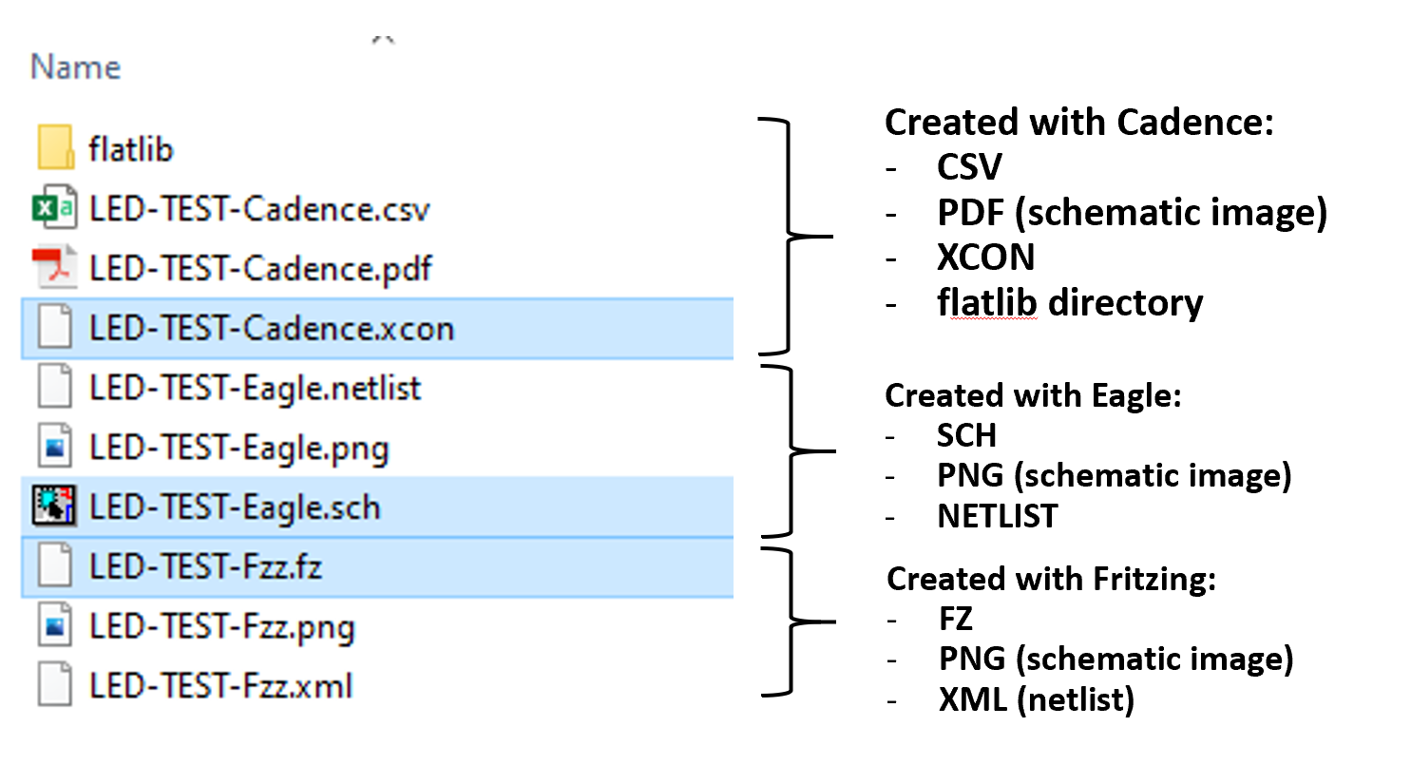

Figure 4. File examples of circuits created with three different third-party software.

## Circuit Created with Cadence

Currently, ModElec only works with Cadence and the part library provided by HP. Three types of files are exported from Cadence: a CSV file, a PDF file, and a XCON file. The *flatlib* folder is needed to use these files in ModElec.

1. To use the 3D models from the HP Cadence part library, check if the part’s JEDEC number is listed in “Cadence-part-list-updated.txt” under the subdirectory “ElectronicPartModels”.
2. To generate the XCON file, save the circuit schematic as a XCON file in Cadence. **Note that the circuit schematic should be placed in the first quadrant in the Cadence page (the left-bottom corner of the circuit blueprint including the frame should be aligned with the origin, *i.e.,* the center with a cross mark, of the canvas).**
3. To generate the PDF file, publish the circuit schematic as a PDF file in Cadence (Figure 5).

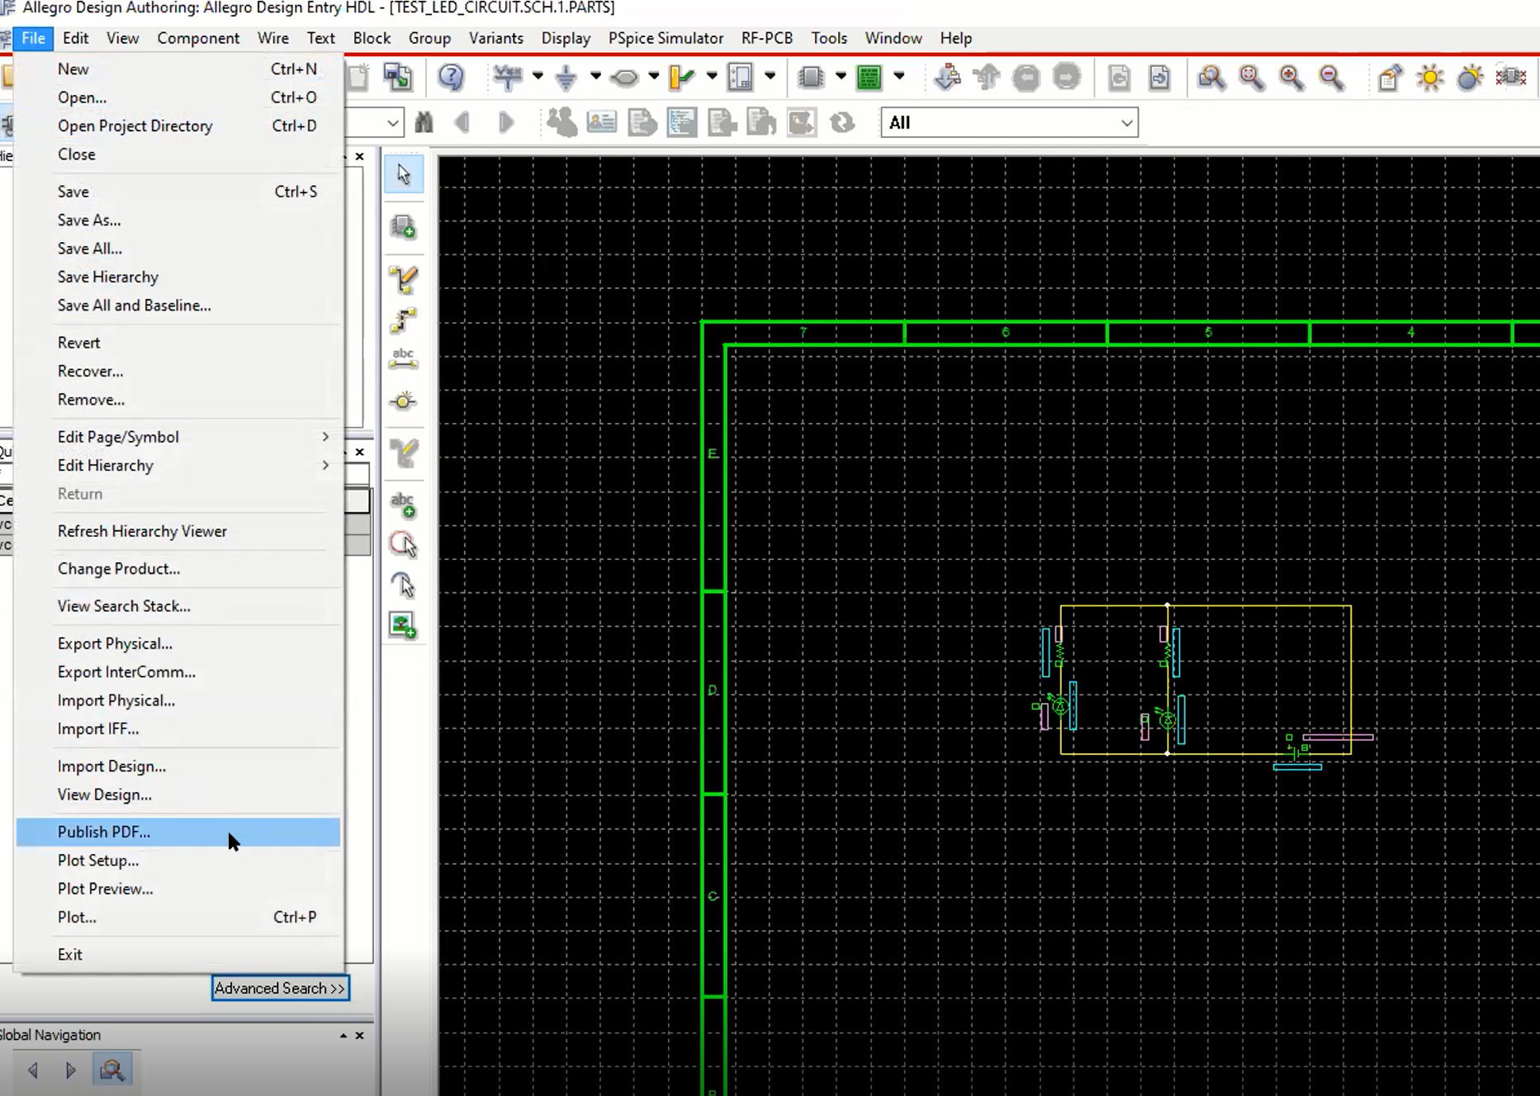

Figure 5. Publish the circuit schematic as a PDF file.

1. To generate the CSV file, go to the working library of the saved Cadence project (the default path is C:\SPD_Data\<circuit project name>\worklib\<circuit project name>\sch_1\ but the *SPD_Data* may vary depends on where the Cadence is installed). Select the CSV file for the active page.
2. Put all the XCON file, PDF file, CSV file, and the *flatlib* folder together in one folder for ModElec to access. A full walkthrough of creating those files and folders are shown in a demo video: **/ModElec/Instructions/Videos/CadenceCircuitPrep.mov**

## Circuit Created with Fritzing

ModElec also supports circuits created with Fritzing. Three types of files are exported from Cadence: a FZ file, a PNG file, and an XML file (Figure 4).

1. To generate the FZ file, save the circuit schematic as an uncompressed file format (*.fz) in Fritzing.
2. Export the schematic as a PNG image file.
3. Export the netlist of the circuit schematic as an XML file.

## Circuit Created with Autodesk Eagle

Finally, ModElec supports circuits created with Autodesk Eagle. Three types of files are exported from Cadence: a SCH file, a PNG file, and an NETLIST file (Figure 4).

1. To generate the SCH file, save the circuit schematic as an SCH file in Eagle.
2. Export the schematic as a PNG image file.
3. Export the netlist of the circuit schematic as a NETLIST file.

# Electronic 3D Package Creator

This tool is developed to help the user create a custom 3D representation of an electronic part that lacks a related 3D model or needs a more appropriate 3D model for a specific application. Like creating custom footprints for electronic parts on a PCB, the user can create a 3D model for a specific electronic component using the dimensions defined in the part’s datasheet and annotate the pin positions with points in Rhino following the part’s PCB footprint. For each pin, the user types in the pin number and name, which can be found in the part’s PCB footprint, and then selects the point that corresponds with the point on the part’s PCB footprint. Below shows an example of annotating pins on a custom 3D model of a Trinket board.

1. Launch Rhino and Grasshopper. Load “3DPackageCreator.gh” in Grasshopper.
2. Create a 3D model for the Trinket board based on the specifications defined in the Trinket’s PCB design and datasheet.
3. In Rhino, add points at the places where the pins locate based on the PCB layout.
4. Type in the pin name in the *Pad Name* textbox.
5. Click the *Add pad position* button and select a point in the Rhino environment. Upon the selection of the point, the pin information (name and position) is recorded and the pin is added to the list (Figure 6).
6. Repeat step 5 to record all the pins.
7. Type in the name for the 3D model in the *File Name* textbox.
8. Save the 3D model using the default *Save* or *Save as* command in Rhino to save the 3D model.
9. Click the *Save model* button in the interface and generate a STL file and an XML file under “\Modelec\” where *3DPackageCreator.gh* and *ModelecMainInterface.gh* are located. The STL file will be used by the ModElec tool and the XML file is used to parse the pin information for the specific electronic part. The STL and XML files share the same name.

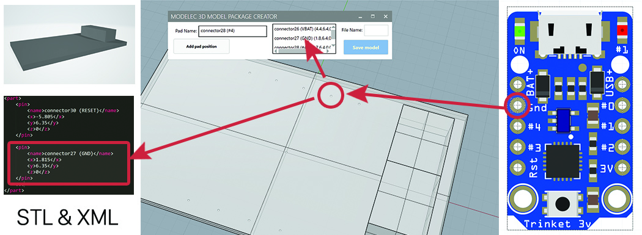

Figure 6. Create a custom 3D representation of an electronic part and record all the pin information using the electronic 3D package creator.

# ModElec Tool Interface

The ModElec design tool is composed of five parts: circuit display, electronic part control, printer profile configuration, 3D printable part control, and trace control (Figure 7). With tool, the user (1) creates a 3D model in the traditional Rhino editing environment; (2) adjust the placement and orientation of a selected electronic part from the imported circuit in the 3D design; (3) adds 3D printable parts such as capacitive touch area and manual traces if needed; (4) previews the auto-generated traces in a 3D layout; (5) iterates the 3D circuit layout and the 3D model design; and (6) exports files for printing.

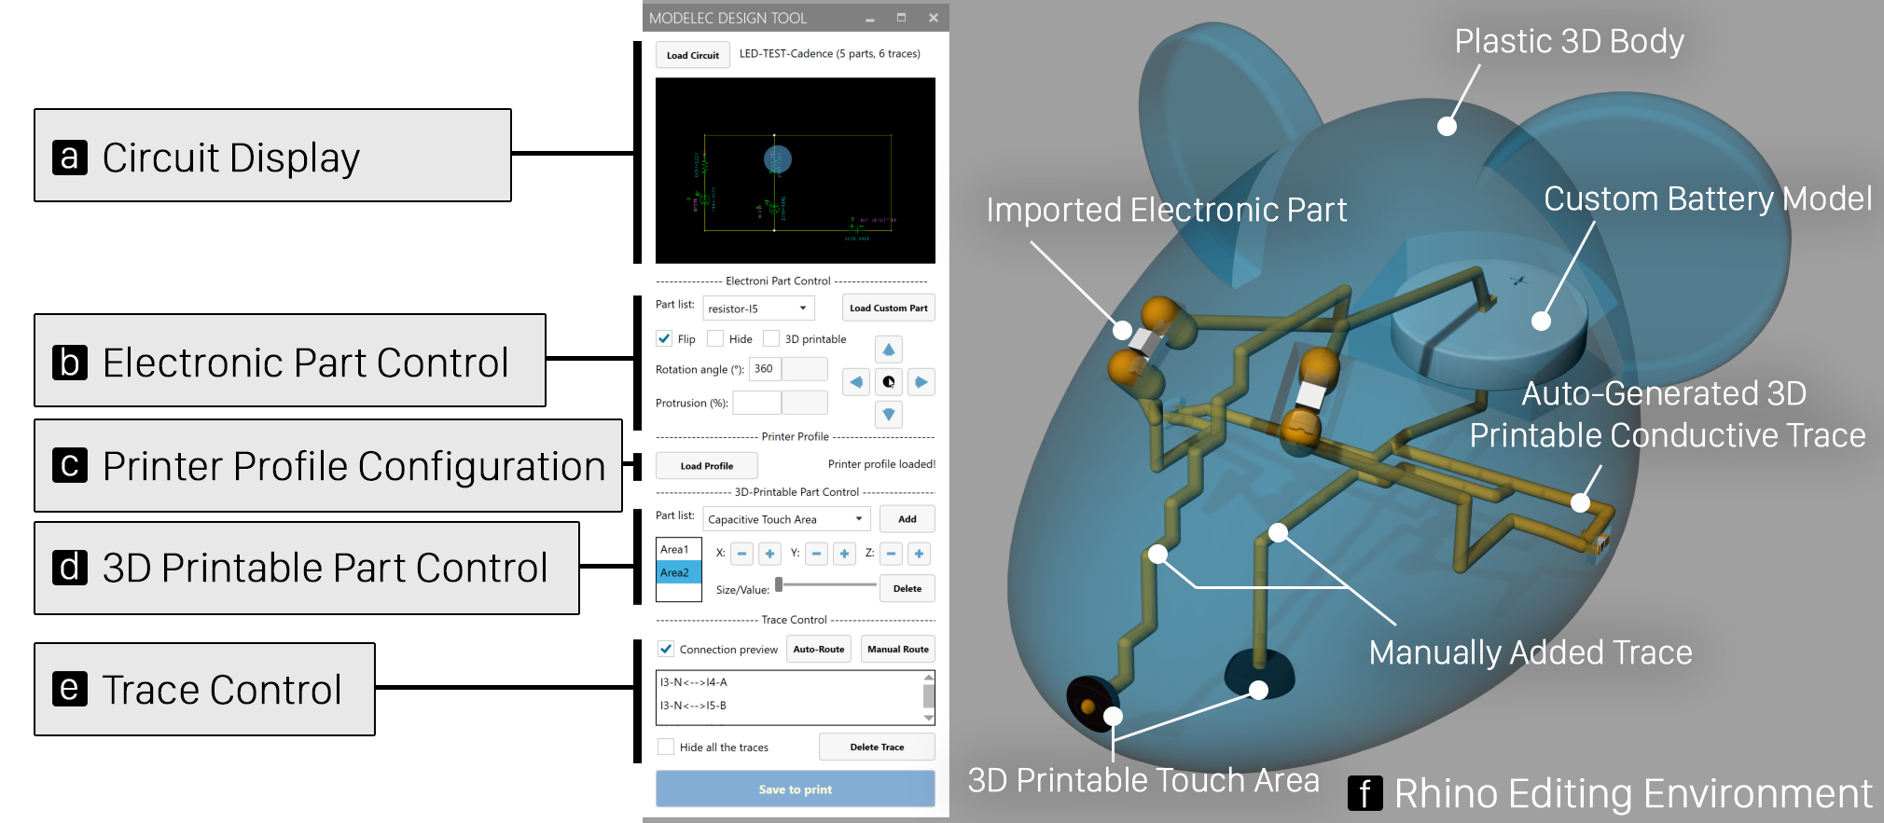

Figure 7. ModElec user interface includes (a) a circuit display, (b) an electronic part control panel, (c) a printer profile configuration panel, (d) a 3D printable part control panel, and (e) a trace control panel. All the imported 3D representations of electronic parts, auto-generated conductive traces, and the converted plastic body are displayed in (f) the Rhino 3D model editing environment.

## Circuit Display

1. Click the *Load Circuit* button and select one circuit schematic file (XCON file for the Cadence circuit, or FZ file for the Fritzing circuit, or SCH file for the Eagle circuit) in the prompted dialogue.
2. The tool asks the user to select a target body (a Brep) in the Rhino environment.
3. After the body is selected, the circuit name along with the amount of parts and traces are displayed.
4. The circuit schematic is shown in the interface.
5. All the electronic parts (if the related 3D models exist) are automatically loaded into the 3D Rhino editing environment.

## Electronic Part Control

**Part A: Select an electronic part and update the 3D representation of the part.**

1. All the electronic parts in the loaded circuit are listed in a dropdown menu (Figure 8). Select a target electronic part by directly clicking one item from the list and the selected part is highlighted in both the Rhino 3D scene and the circuit schematic.
2. If the part does not have a corresponding 3D representation or an alternative 3D model is available for the part, click the *Load Custom Part* button to use a custom 3D representation for the part. The custom part model will be added to the body or substitute the original model.

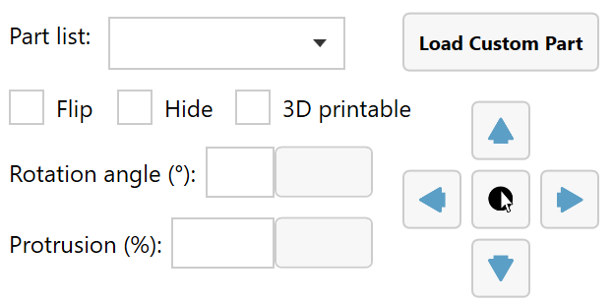

Figure 8. The electronic part control panel in the ModElec design tool.

**Part B: Move, quickly relocate, and nudge the electronic part.**

After one electronic part is selected, the part can be freely moved around in the Rhino 3D scene by dragging. The tool also offers two other part moving options: *Quick-Positioning* and *Part-Nudging*.

For Quick-Positioning,

1. Click the button that has black dot with a hover mouse icon on the right side to trigger all the candidate locations on the body’s surface, which are represented by points (Figure 9a).
2. Click somewhere in the Rhino editing environment to activate Rhino. Rotate the Rhino 3D scene and seek for a potential place. When the cursor hovers over those points, the point closest to the cursor turns into a bigger blue sphere with a red line indicating the normal direction of the point on the surface (Figure 9a).
3. After a desired point is clicked, the electronic part moves immediately to that place and all the candidate points disappear.

For Part-Nudging,

1. Move the part to the nearby positions in four directions by clicking those four buttons that have blue arrows.

Since all the external electronic parts will be manually assembled after the body and traces are printed, the part snaps to the body’s exterior surface automatically after each move and faces in the normal direction of the point on the surface for the ease of post-print assembly. In addition, the tool also inspects if electronic parts overlap with each other after every part moves and prompts an error if any intersection is found.

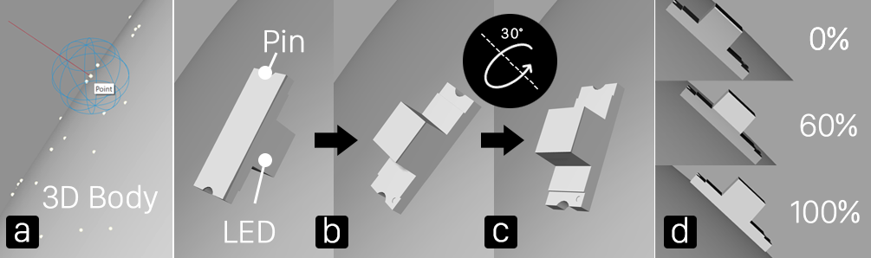

Figure 9. The tool supports (a) quick part positioning, (b) part flip, (c) in-place part rotation, and (d) part protrusion.

**Part C: Flip, rotate, and protrude the electronic parfait in place.**

1. If the electronic part’s pins are outside of the 3D body, flip the part by checking the *Flip* checkbox and submerge the pins under the body surface (Figure 9b).
2. Electronic parts are constrained to rotate only around the normal axis of the part position on the surface for the consideration of part assembly (Figure 9c). After typing in a rotation angle (in degree) in the textbox, the tool rotates the part by the input angle in the counterclockwise direction around the normal axis.
3. When the electronic part is initially positioned on the body surface, the entire electronic part body is fully embedded by default. Move the part along the normal direction of the part position on the surface to expose partial of the part body (Figure 9d). Type in the protrusion ratio in percentage (0-100%) and the tool moves the part accordingly.

**Part D: Other electronic part controls.**

Hide an individual electronic part and opt to use a 3D printable version for a specific part (Figure 8). If the part is set as a 3D printable version, the socket for that part will not be generated.

## Printer Profile Configuration

Similar to the design rules applied for regulating the trace routing in PCB design workflow, design criteria applied to the printer for conductive 3D printing is critical in the design and fabrication of conductive traces and electronic parts. To support distinct design rules for different compatible 3D printers, the ModElec tool parses printing specifications that are defined in a JSON formatted file—*printer profile*—and the user needs to load a printer profile before moving on to add 3D printable electronic parts and traces. **Note this is mandatory for a successful trace generation.** “MJF-testbed.json” under /Modelec/PrinterProfile/ shows an example of the printer profile for the HP MJF testbed.

## 3D Printable Electronic Part Control

To broaden the spectrum of 3D printable electronics enabled by the multi-material-based 3D printer, the tool provides three different electronic components for custom circuit design: connection nodes, capacitive touch areas, and resistors (Figure 10).

**Part A: Connection nodes.**

Spheres can be generated inside or on the surface of the 3D body as junction nodes such as those for connecting multiple traces and electronic parts in the circuit schematics (Figure 10b).

1. Click the *Add* button to add a connection node.
2. Change the node’s position along the X/Y/Z axis by clicking on those directional buttons and resize the node by controlling a slide in the interface (Figure 10a).
3. The connection node is added to a list and can be deleted by clicking the *Delete* button (Figure 10a).

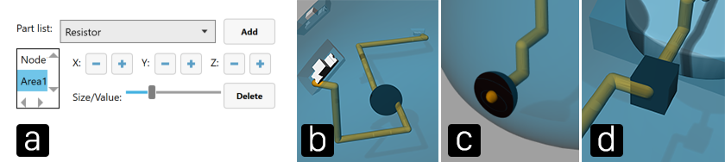

Figure 10. The user can control (b) a connection node, (c) a capacitive touch area, and (d) a resistor through the (a) 3D printable part control panel in the user interface of the ModElec design tool.

**Part B: Capacitive touch areas.**

A conductive region can be added and exposed on the 3D body’s exterior surface as interactive touch pads using capacitive sensing (Figure 10c).

1. Upon selecting from the dropdown list, all the available locations are shown as points and select one point like that for *Quick-Positioning* to place the touch area.
2. The touch area moves only on the object’s surface when clicks on those directional buttons and resizes in response to the slider changes.

**Part C: Resistors.**

The tool also supports the creation of 3D printable resistors (Figure 10d). In similar operations, the added resistor can move along the X/Y/Z axis in the body. However, the slider is used for controlling the resistor’s resistance. As the slider value changes, the resistor changes its length and cross-sectional area based on the resistivity specifications defined in the printer profile. Currently, the tool offers an approximate estimation rather than an accurate resistor’s resistance by controlling the slider.

## Trace Control

The tool allows the designer to preview the logic connections between electronic parts, execute auto-route based on the existing circuit schematic, and manually add traces (Figure 11).

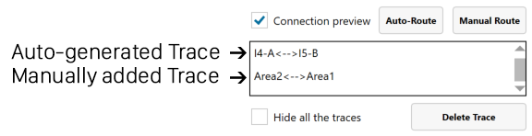

Figure 11. The trace control panel in the ModElec design tool.

**Part A: Logic connection preview.**

Before the actual traces are deployed, the tool offers a preview of all the part connections by displaying red straight curves between the pins in the 3D body (Figure 12a). Like the logic connections in the traditional PCB design, these curves indicate the logic connections between pins rather than the real routing.

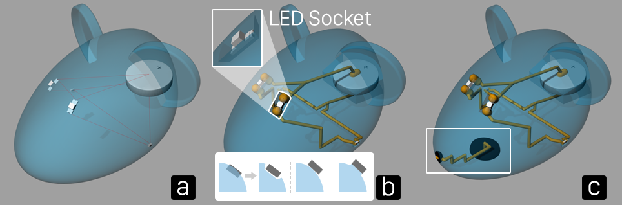

Figure 12. The tool provides (a) logic connection preview for the user and converts the body by creating (b) part sockets and auto-generated traces. The user can also (c) manually add traces to the body.

1. Check the *Connection Preview* checkbox to turn on these curves.
2. Use these curves to inspect if the traces have potential crossings in the 3D space before the actual traces are generated.
3. If all the circuit traces are generated successfully, the red connection curves disappear. A residual curve indicates that the tool fails to generate a 3D trace between the two pins.

**Part B: Sockets for hosting the electronic parts.**

To host the external electronic parts on the 3D body’s exterior surface, the tool creates sockets for the electronic parts as the traces are generated (Figure 12b). These sockets are inverted truncated pyramids that are perpendicular to the body surface. If the electronic part is switched to a 3D printable part by the user, no part socket will be created. Note that the sockets will be automatically generated along with the traces when either the *Auto-Route* button or the *Manual Route* button is clicked.

**Part C: Auto-route.**

1. Click the *Auto-Route* button, the traces will be generated based on the connections in the circuit schematic (Figure 12c).
2. The generated traces are added to a list (Figure 11).
3. The manually added 3D printable parts will not be connected to any parts since the 3D printable parts and their connection information are not recorded in the circuit schematic.

**Part D: Manual-route.**

Beside the auto-generated traces, traces can be manually added to connect electronic components.

1. Click the *Manual Route* button, the tool prompts to ask to specify the position of the start point for the trace. For the point position, the tool accepts three types of objects: a part pin, a 3D printable part, and an already generated trace.
2. Type *1* for an electronic part, *2* for a 3D printable part, or *3* for a trace.
3. Click somewhere in the Rhino editing environment to activate Rhino. Move the cursor around the 3D model and the closest corresponding type of part will be highlighted.
4. Click to confirm the selection of the starting position of the trace. Hit *Enter* to continue.
5. The tool prompts to ask to specify the position of the end point for the trace.
6. Type *1* for an electronic part, *2* for a 3D printable part, or *3* for a trace.
7. Click somewhere in the Rhino editing environment to activate Rhino. Move the cursor around the 3D model and the closest corresponding type of part will be highlighted.
8. Click to confirm the selection of the starting position of the trace. Hit *Enter* to finish the input of the manual trace.
9. The trace is automatically generated in the Rhino editing environment and the newly added manual trace is added to the list (Figure 11).

**Part E: Other trace operations.**

1. The generated traces are listed in the interface so that a trace can be selected by clicking it in the list (Figure 11). The selected trace is highlighted in the Rhino 3D scene.
2. Hide all the generated traces by clicking the *Hide all the traces* button.
3. Remove a selected trace from the currently embedded circuit by clicking the *Delete Trace* button.

## Save Models for Print

Click the *Save to Print* button and three new layers are generated:

1. “Conductive” Layer - the generated traces are stored and can be saved as a single STL file for conductive printing.
2. “Plastic” Layer - the converted body with the internal traces and socket pads subtracted is stored and can be saved as a single STL file for non-conductive printing.
3. “DA” Layer - a set of detail agent regions are automatically generated around the exposed conductive regions to protect and warrant the conductive areas during the printing process. They can be saved as a single STL file for printing.